



Essay / Assignment Title: Big Data Analytics with Apache Spark and Hadoop Ecosystem
Programme title: Big Data Analytics
Name: Naga Surendera Bsbu Aravapalli
Year: 2025

CONTENTS

Table of Contents
CONTENTS 2
INTRODUCTION 7
1. CHAPTER ONE 9
1.1 Business Context 9
1.5 Big Data Technology: - 10
1.6 Uses of Big Data Technology: - 11
1.6.1 When it is a Big Data Technology: - 11
1.6.2 When it is not a Big Data Technology: - 12
1.7 Hadoop: - 12
1.7.1 How Hadoop Works: - 12
1.7.2 Hadoop Components: - 12
1.7.3 Hadoop Advantages and Disadvantages: - 13
1.8 Failure Tolerance: - 13
1.9 Hadoop Framework: - 14
1.10 Map Reduce: - 14
1.11 Explanation about the project: - 15
1.11.1 Project Overview: 15
1.11.2 CarSales Dataset: - 15
2. CHAPTER TWO 17
2.1 Cluster Setup Steps: - 17
2.2 Terminal Code: - 19
2.3.1 Dashboards: - 21
2.3.2 Hadoop Browse Directory 22
2.3.3 Hadoop Startup Progress 22
2.3.4 Hadoop Overview 23
2.3.5 Datanode Volume Failures 24
3. CHAPTER THREE 25
3.1 PySpark 25
3.2 Columns of Dataset: - 25
3.3 Statistical summary of the Dataset: - 26
3.4 Data Cleaning: - 27
3.5 Features and K-Means Clustering: - 28
3.6 Confusion Matrix: - 29
3.7 Silhouette scores: - 30
4. CHAPTER FOUR 31
4.1 Clustering Visualization: - 31
4.2 Price Distribution by Cluster: 32
4.3 Linear Regression Model Accuracy: - 33
4.4 Actual V/s Predicted Prices: - 34
4.5 Residuals V/s Predicted Prices: - 35
4.6 Residuals Distribution: - 36
4.7 Linear Regression Model Coefficients & intercept: - 36
5. CONCLUDING REMARKS 38
5.1 Observations: - 38
5.2 Recommendations: - 38
6. BIBLIOGRAPHY 39
APPENDIX (if necessary) 40

List of Figures: -
Figure 1 Failure Tolerance 13
Figure 2 Hadoop Framework 14
Figure 3 Map Reduce 14
Figure 4 HDFS & Jupyter Lab links to open 17
Figure 5 Dataproc Clusters 18
Figure 6 Cluster Running 19
Figure 7 Terminal Code -1 19
Figure 8 Terminal Code -2 20
Figure 9 Terminal Code -3 20
Figure 10 Hadoop Dashboards 21
Figure 11 Hadoop Browse Directory 22
Figure 12 Hadoop Startup Progress 22
Figure 13 Hadoop Overview 23
Figure 14 Hadoop Summary 23
Figure 15 DFS Storage & NameNode status 24
Figure 16 Datanode volume Failures 24
Figure 17 PySpark to read HDFS file 25
Figure 18 Descrbe dataset 25
Figure 19 Statistical Summary 26
Figure 20 Data Cleaning 27
Figure 21 K-Means Clustering 28
Figure 22 Confusion Matrix 29
Figure 23 Silhouette scores 30
Figure 24 Clustering Visualization 31
Figure 25 Price Distribution by Cluster 32
Figure 26 LR Prediction & Accuracy Matrix 33
Figure 27 LR Actual Vs Predicted Price 33
Figure 28 Residuals Vs Predicted Prices 34
Figure 29 Residuals Distribution 34
Figure 30 LR Model Coefficients & intercept 35

Statement of compliance with academic ethics and the avoidance of plagiarism

I honestly declare that this dissertation is entirely my own work and none of its part has been copied from printed or electronic sources, translated from foreign sources and reproduced from essays of other researchers or students. Wherever I have been based on ideas or other people texts I clearly declare it through the good use of references following academic ethics.
(In the case that is proved that part of the essay does not constitute an original work, but a copy of an already published essay or from another source, the student will be expelled permanently from the program).

Name and Surname (Capital letters): NAGA SURENDERA BABU ARAVAPALLI
Date: 04/10/2025

INTRODUCTION

In the Present digital marketplace, e-commerce platforms produce enormous amounts of data from customer interactions, transactions and response. Product reviews play a crucial role as they impact purchasing choices and provide feedback t osellers, but their high volumes, speed and diversity pose challenges for conventional systems. Big Data analytics, utilizing tools like Apache Hadoop and Spark, facilitates the effective processing large-scale datasets.
This project explores customer sentiment and trends by analyzing review and sales data, with focus on the CarSales dataset to pinpoint leading car brands in different countries. The 5V’s of Big Data - Volume, Velocity, Variety, Veracity, and Value – underscore its capability to manage variety of data generated rapidly for actionable insights. The extended 7Vs also include Variability and Visualization.
Utilization of Hadoop and Spark, It illustrates the how distributed computing and machine learning can extract insights to improve decision-making and enhance customer engagement. Big Data is essential for making data-driven choices in industries such as retail and automotive, although it is not as effective for smaller, structured datasets. The CarSales Customer Reviews Dataset used for analyzing sales trends.
Finally, it concludes how Big Data converts unstructured information into strategic insights by enhancing business decisions and competitiveness.
Methodology: -
This initiative makes with Apache Spark and Hadoop on Google Dataproc to examine the CarSales dataset. Important steps consist of:
Cluster Setup: Create a Dataproc cluster that includes master and worker node, making use YARN for managing resources and HDFS for storing data in a distributed manner.
Data Uploading: Loaded the CarSales dataset into HDFS using hdfs dfs -put, confirmed with hdfs dfs -ls. HDFS separates data into blocks of 128MB, with three copies for reliability.
Hadoop Processing: Implemented MapReduce for simultaneous processing, enhancing data locality. YARN managed job scheduling while monitoring the distribution of HDFS blocks.
Spark Analysis: Applied Spark’s ability for in-memory processing to conduct analytics efficiently, used spark SQL for querying sales based on brand and country and Spark MLlib for clustering and possible sentiment evaluation. (Ref#7 Luckow, A., 2015)
Validation and Insights: The HDFS files and gathered insights regarding the best-selling regions and brand trends have confirmed the integrity and presented through Spark visualization.
This approach guarantees reliable and scalable processing, effectively tackling the 5Vs of Big Data: Volume, Velocity, Variety, Veracity and Value.

1. CHAPTER ONE

1.1 Business Context
The car industries have large amounts of online retail transactional data from customer feedback and sales records pose difficulties for conventional systems. Customer reviews influencing the buying choices and revealing trends because demand trends patterns directed by location wise sales figures.
The unstructured Carsales customer reviews dataset is extremely large that require powerful Big Data tools for tasks like sentiment evaluation and tailored experiences. The CarSales dataset focuses on auto brand sales across various countries to identify top markets and emerging trends.
Big Data technologies such as Hadoop and Spark offer efficient storage solutions (HDFS), parallel processing capabilities (MapReduce/YARN) and sophisticated data analysis (Spark MLlib). These technologies allow for immediate sentiment evaluation in online retail and assist in grouping auto sales trends. Advantages include enhanced customer satisfaction, lower expenses and faster decision-making.
1.2 What is Big Data:
Big Data is one of the most important transformative technologies in the modern business and research world. It enables the organizations to process and analyze the high volumes of data independently. It can handle the rapid growth of business transactions digitally, social media activity, sensor data, and customer interactions, which creates both opportunities and challenges for businesses.
1.3 Characteristics of Big Data: -
Big Data has majorly repeated characteristics, which are called the 5V’s: volume, variety, velocity, value, and veracity.
Volume: It refers to the amount of data.
Velocity: It means the speed of the data processing.
Variety: Indicates the different types of data.
Veracity: The accuracy, quality, and trustworthiness of the data being analyzed.
Value: Actionable insights
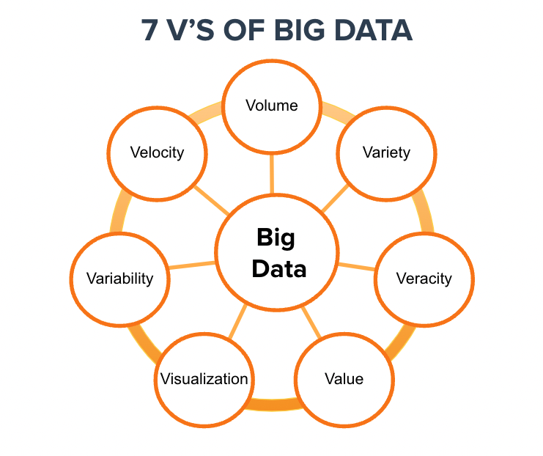
1.4 Importance of Big Data: -
In today's high-volume transactional environment, big data is essential for businesses to make informed decisions, understand customer purchasing behaviors, and optimize everyday operations for greater efficiency.

1.5 Big Data Technology: -
Big data refers to massive and rapidly growing datasets that traditional databases cannot easily handle. It is used in machine learning, predictive modeling, and advanced analytics to solve business problems and support informed decision-making.
Common Big Data tools and frameworks include
Storage & Processing:
- Hadoop (HDFS, YARN, MapReduce)
- Apache Spark (fast in-memory processing)
Data Streaming:
  - Apache Kafka
  - Flink
Databases:
  - NoSQL (MongoDB, Cassandra, HBase)
  - Relational (MySQL, PostgreSQL for smaller structured data)
Machine Learning & Analytics:
  - Spark MLlib
  - TensorFlow, Scikit-learn
Cloud Platforms:
  - Big Data & Analytics Platforms: Cloudera, Google Cloud, AWS EMR, Azure HDInsight, Google BigQuery, Databricks
- Containerization & Deployment: Docker
These tools help businesses to manage and analyze large-scale data. It helps to extract valuable insights and make smarter, effective business decisions.

1.6 Uses of Big Data Technology: -

1.6.1 When it is a Big Data Technology: -
Big Data technology is used when it satisfies the 5V’s. It supports advanced analytics, Machine Learning, and real-time decision-making relating to the various car sales. There are respective roles for different departments like finance, retail, healthcare, and manufacturing.
  - Volume: The dataset is large in extent, typically in terabytes or petabytes.
  - Velocity: Data is generated and processed at high speed, often in real time.
  - Variety: Data comes in multiple forms - structured, semi-structured, and unstructured.
  - Veracity: Data quality and accuracy are variable but crucial.
  - Value: The data delivers actionable insights and real business value.

1.6.2 When it is not a Big Data Technology: -
  - The data volume is small or manageable by standard databases.
  - Data is mostly structured and simple in nature.
  - Real-time or fast processing is not required.
  - The organization lacks the infrastructure or expertise to handle Big Data.
  - Traditional tools suffice for the intended data processing and analysis needs.

1.7 Hadoop: -
Hadoop is an open-source software framework that utilizes distributed data storage and parallel processing on clusters of commodity hardware to handle a vast volume of datasets in big data.
It consists of the Hadoop Distributed File System (HDFS) for Data storage and MapReduce (or YARN in newer versions) for processing, which allows organizations to store and analyse the large amounts of data efficiently and cost-effectively.

1.7.1 How Hadoop Works: -
Hadoop splits large datasets into smaller pieces and distributes them across a cluster of many computers or nodes.

1.7.2 Hadoop Components: -
- Hadoop Distributed File System (HDFS): - It handles the distributed storage of large datasets.
- YARN (Yet Another Resource Negotiator): - It administers the computing resources and schedules jobs to run across the cluster.
- MapReduce: - It processes large datasets in parallel for the programming model and execution of the engine.

Why it Matters: -
- Hadoop provides process efficiency and a cost-effective way for organizations.
- Store Big data: Hadoop can store virtually any kind of data, whether it is structured or unstructured.
- Quick data transmission: Faster data analysis, and can quickly respond to queries.

1.7.3 Hadoop Advantages and Disadvantages: -
Advantages of Hadoop: - cost-effectiveness, Scalability (adding more servers to a cluster), Fault Tolerance (data is not lost and processing continues), Flexibility with any kind of data types, Open-source availability, and Data Locality.
Disadvantages of Hadoop: - High latency for interactive queries, Complexity in programming management, and critical to apply for small or real-time data.

1.8 Failure Tolerance: -
HDFS acts like a backbone of Hadoop’s failure tolerance mechanism. It stores the files in a sequence of three blocks and each block connected to the multiple machines in the cluster by default. It means data exist in other two blocks if any one node lost the data due to hardware failure. Hence, it is easy to reconstruct the lost and it ensures the Hadoop system can tolerate failures without any data loss.
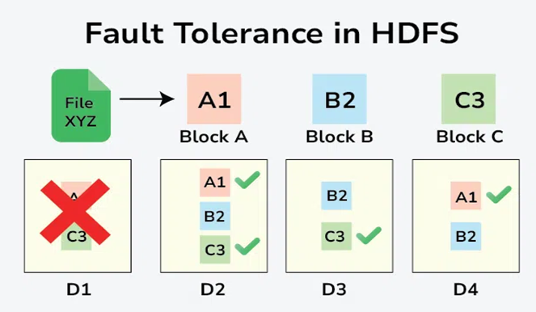
Figure 1 Failure Tolerance

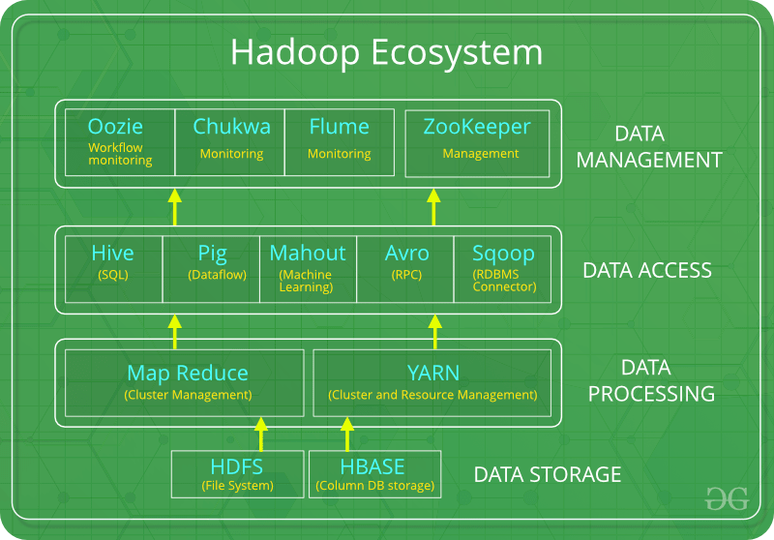
1.9 Hadoop Framework: -
Figure 2 Hadoop Framework

1.10 Map Reduce: -
The Map reduce is a processing engine of Hadoop system where HDFS stores the big volume of data and MapReduce handles the actual computation and analysis part.
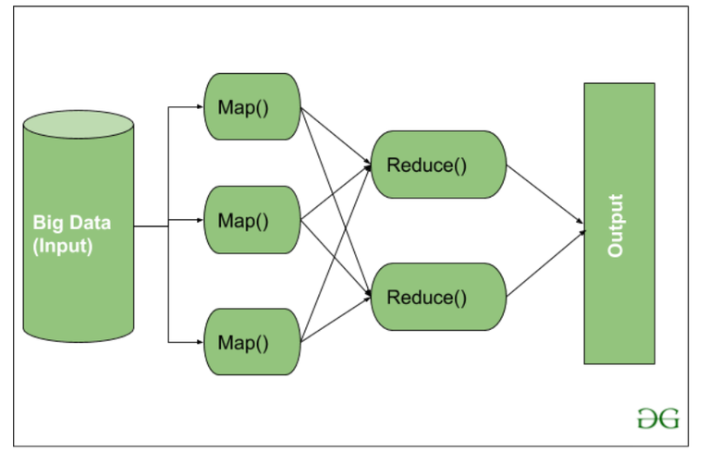
Figure 3 Map Reduce
- File system: - It has specific requirements as per the Operating Systems. OS follow the operating system like
Windows directory: Win – NTFS (New Technology File System)
Linux: Use EXT. file system (i.e EXT 1MB)
- Block: - It split the data into three blocks.
- Client & Server
- Types of File system
- Types of Distribution file system
- Types of Process
- Cluster 2 Node
- API

1.11 Explanation about the project: -

1.11.1 Project Overview:
This is about to explain the car sales dataset across the all countries in the world. I need to find the which car sales have more across all the countries and to be analyzed in various views. This project initiates analysis of car sales information from various brands and countries to highlight top-performing markets and trends. It uses Hadoop and Spark to process large data sets, aiding decisions in the automotive sector such as inventory control and marketing strategies. The project aggregation and identifying patterns (such as seasonal trends) through analytics and machine learning techniques.

1.11.2 CarSales Dataset: -
The Dataset relates to Car Sales of different brands across different countries. I need to find which sales have more across all the countries. The Dataset contains a huge volume of records, so it has Vs.
Volume: Substantial, potentially had terabytes, making it suitable for Big Data.
Variety: Semi-structured CSV format containing fields such as brand, model, country, sales, price and date.
Velocity: Regular updates (for instance, daily sales).
Veracity: Potential inaccuracies that necessitate data cleaning.
Value: Provides insights into leading brands, regional demand and market trends.

2. CHAPTER TWO

Google Dataproc cloud platform has been chosen and used for a Big Data Processing environment to run Spark and Hadoop.

2.1 Cluster Setup Steps: -
These screen shots explain about to configure and run a Google Dataproc cluster for processing the CarSales dataset using Hadoop and Spark. Below are the insights for each one:
First created a Google Cloud account and generated the clusters.
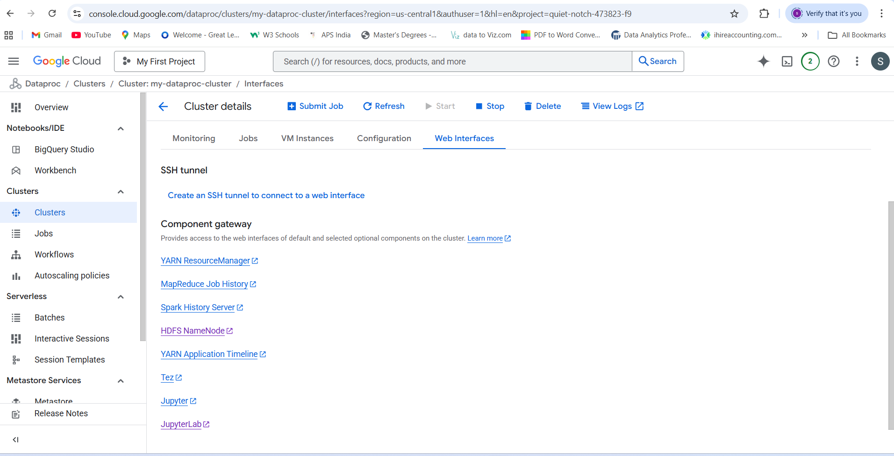
Figure 4 HDFS & Jupyter Lab links to open

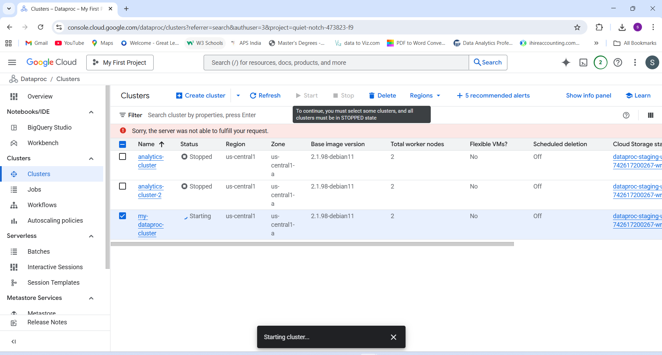
Figure 5 Dataproc Clusters
Insight:
The Dataproc Clusters screen shows three clusters named as cluster, cluster-2 and my_dataproc_cluster.
The first two are not active and both have 2 worker nodes with a version 2.1.0-debian11 image. My Dataproc cluster is in the process of starting up but other two are in stopped status.
Running: - The Dataproc cluster is in running status now.
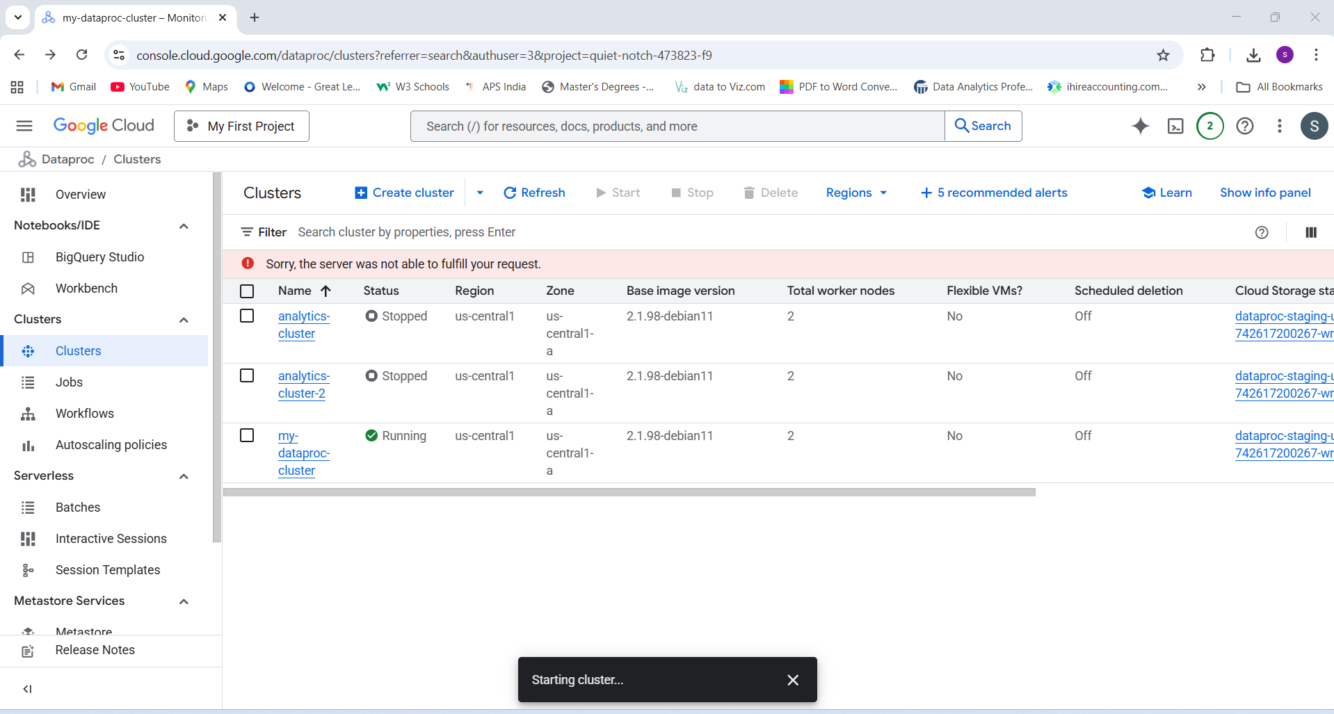
Figure 6 Cluster Running

2.2 Terminal Code: -
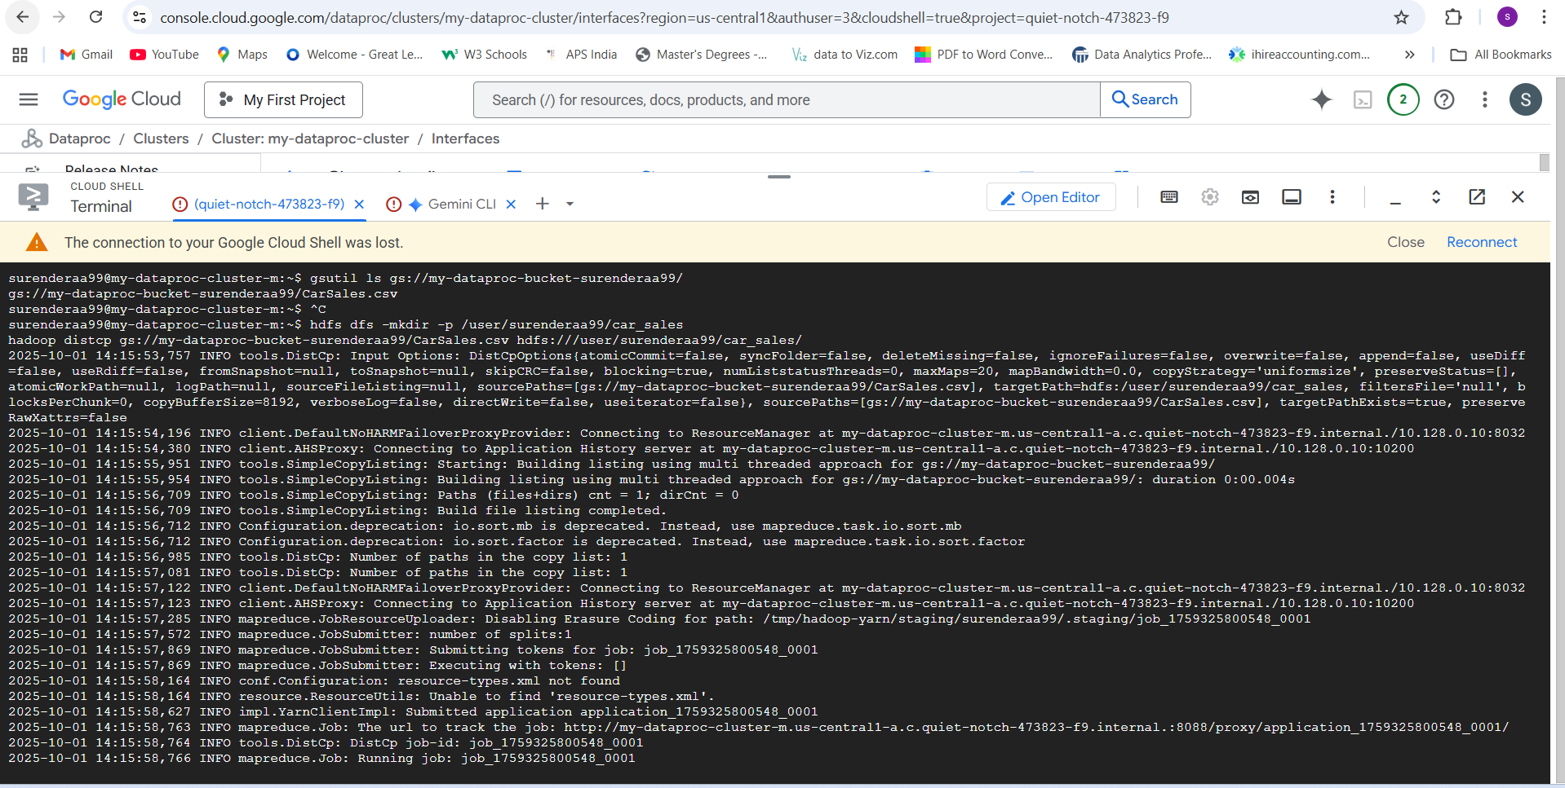
Figure 7 Terminal Code -1

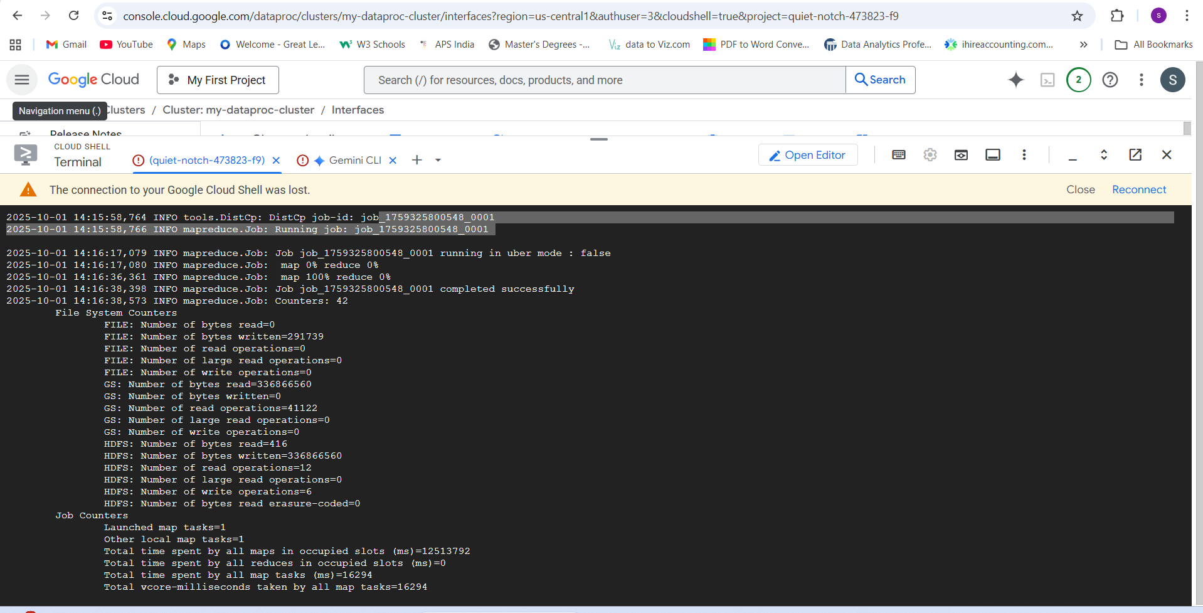
Figure 8 Terminal Code -2
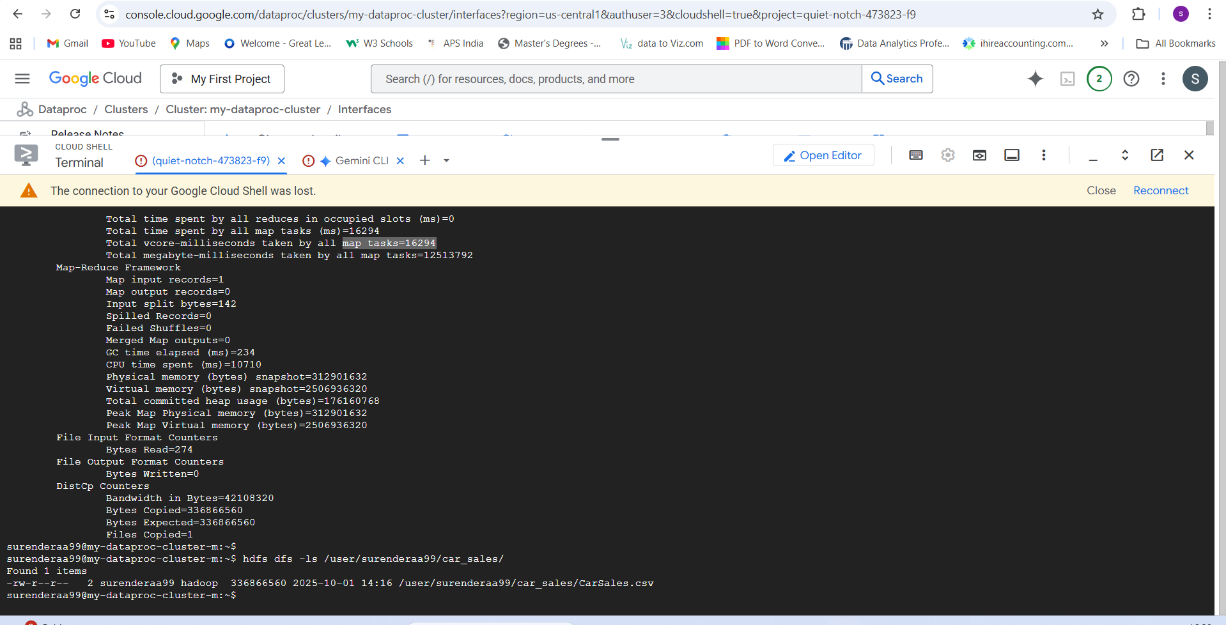
Figure 9 Terminal Code -3
Insight:
- The Dataproc terminal indicate commands to upload or handle the CarSales dataset during the configuration phase. The terminal shows that a MapReduce job completed successfully on my_dataproc_cluster. It indicates the amount of bytes read and written and includes formats, confirming effective data processing using HDFS and MapReduce. A connection loss is recorded after the process finished.
- This terminal proivdes comprehensice MapReduce statistics for my_dataproc_cluster, outlining total duration, time taken for mapping/reducing and counters for splits, bytes and memory consumption. So it ocnfirms the effective processing of the CarSales dataset with successful mapping and reducing tasks.
2.3 Hadoop for dataset: -

2.3.1 Dashboards: -
HDFS File Distribution. Screenshots for Hadoop file details and its status.
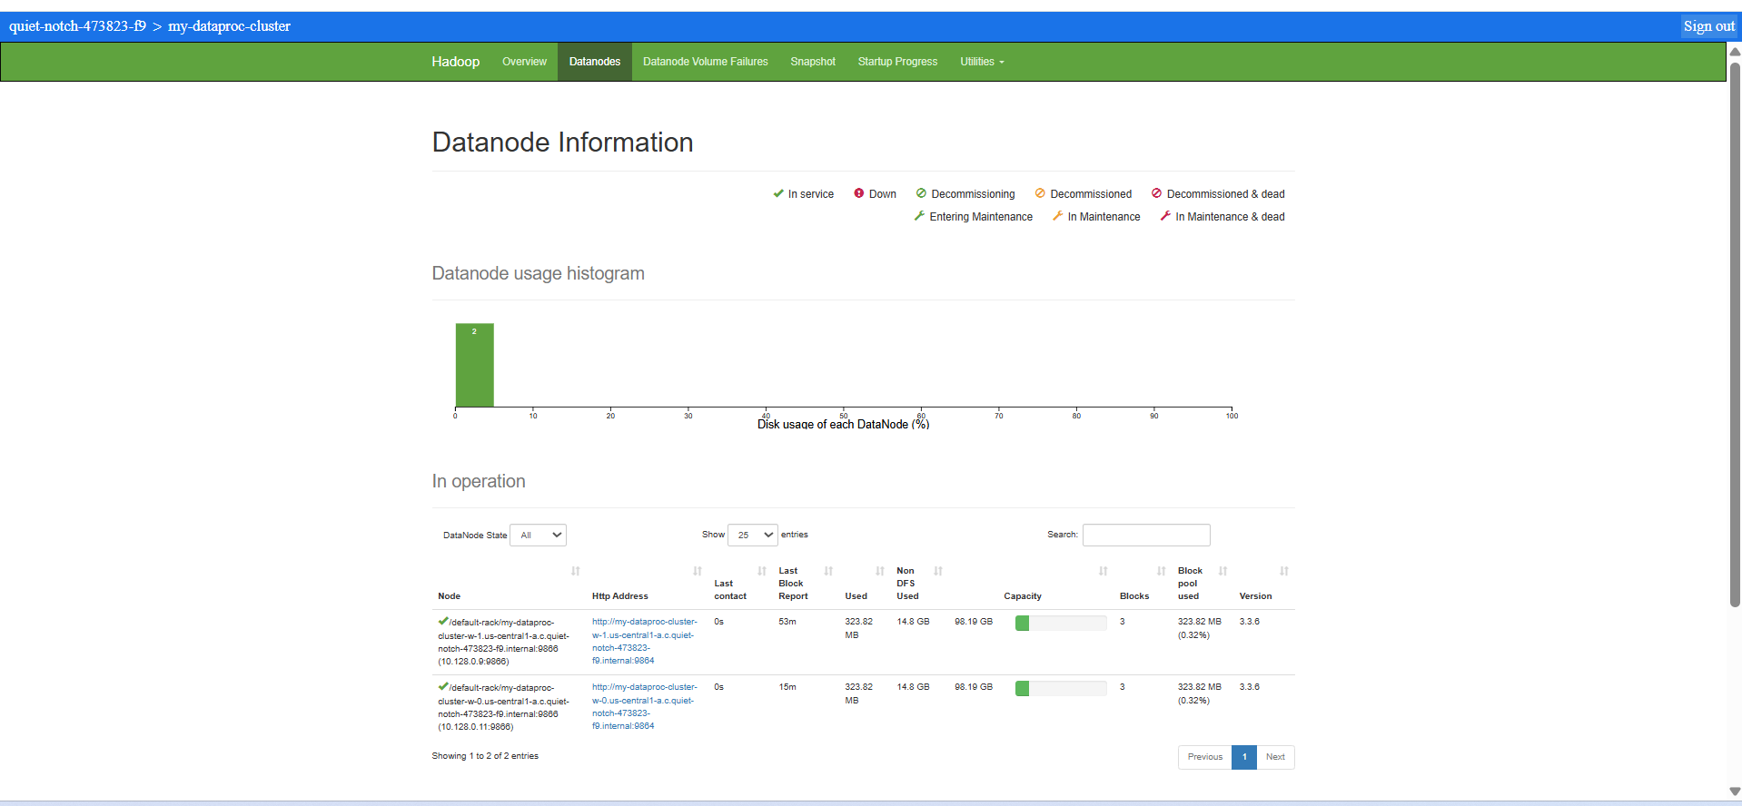
Figure 10 Hadoop Dashboards

2.3.2 Hadoop Browse Directory
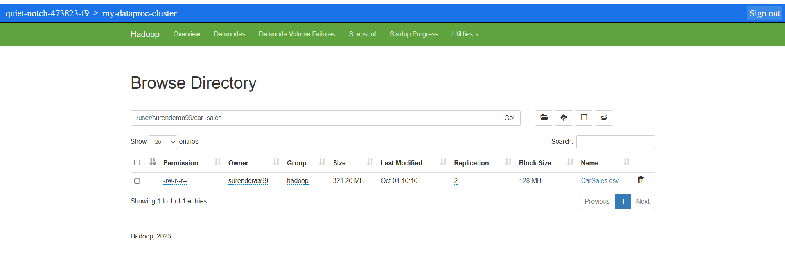
Figure 11 Hadoop Browse Directory

2.3.3 Hadoop Startup Progress
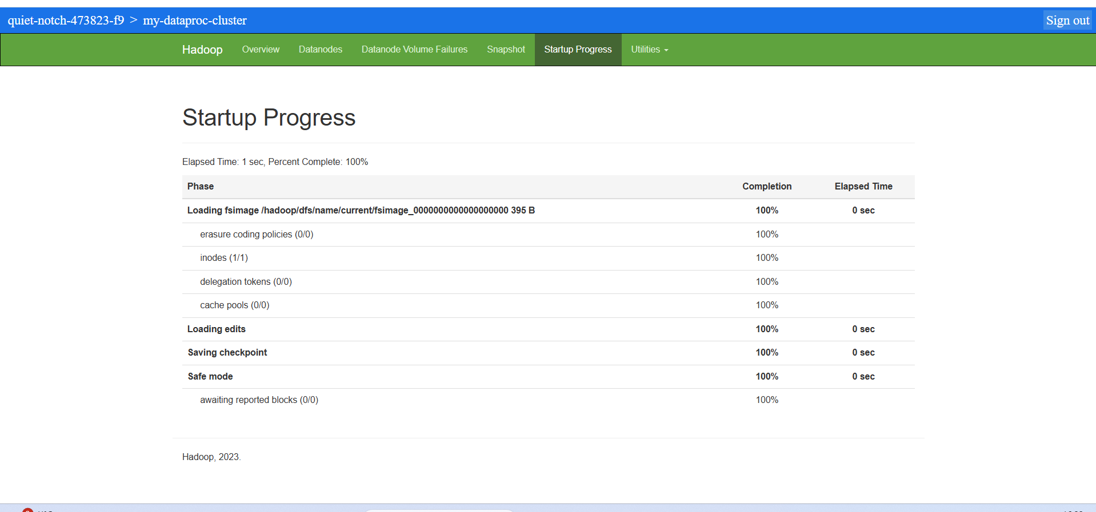
Figure 12 Hadoop Startup Progress

2.3.4 Hadoop Overview
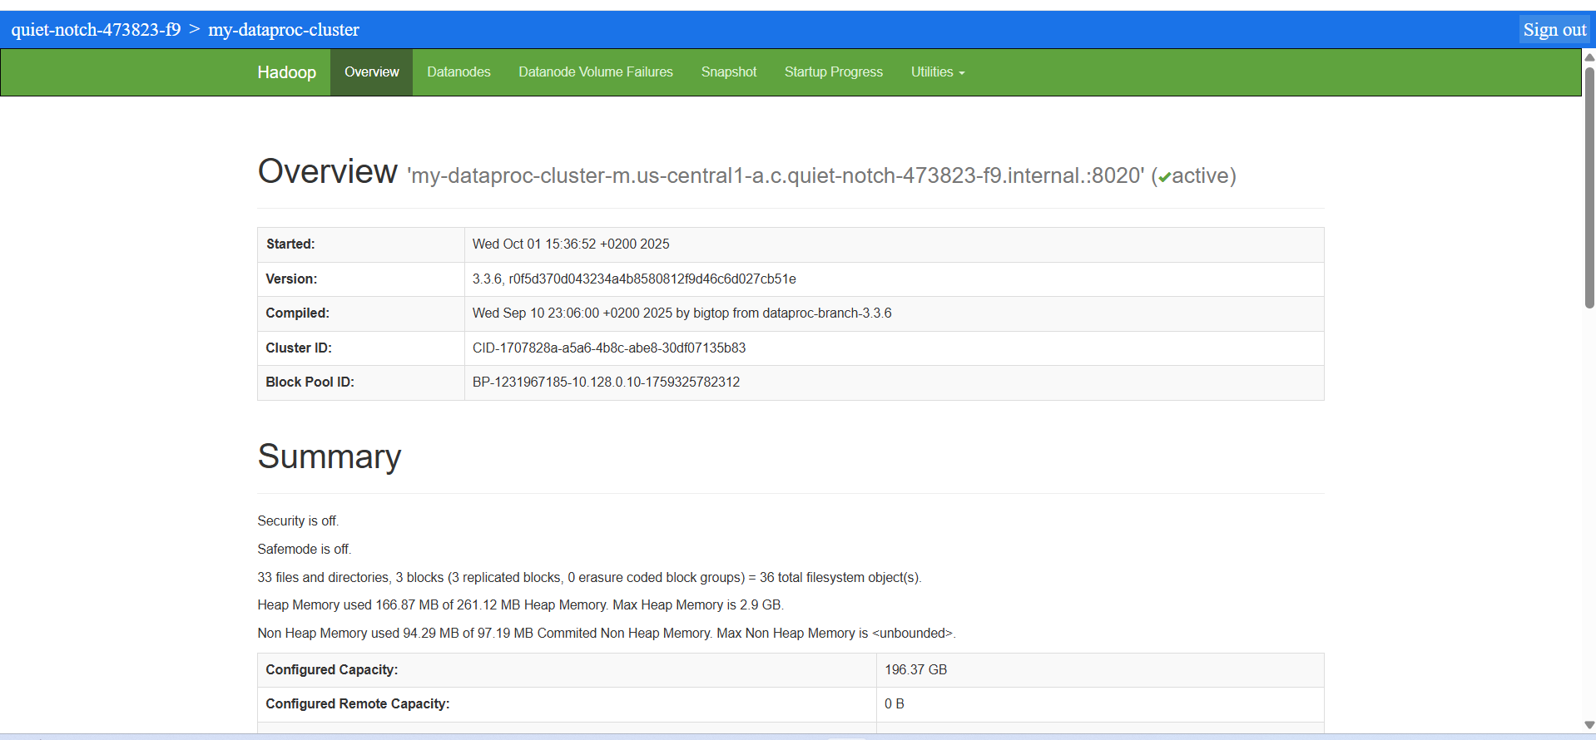
Figure 13 Hadoop Overview
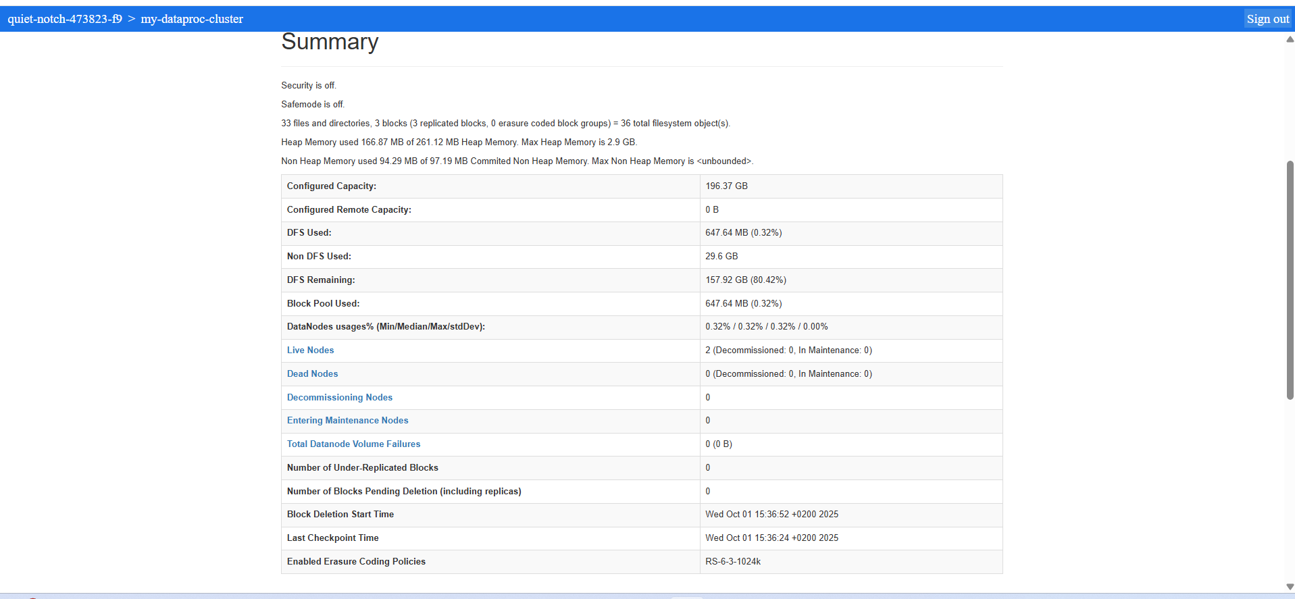
Figure 14 Hadoop Summary

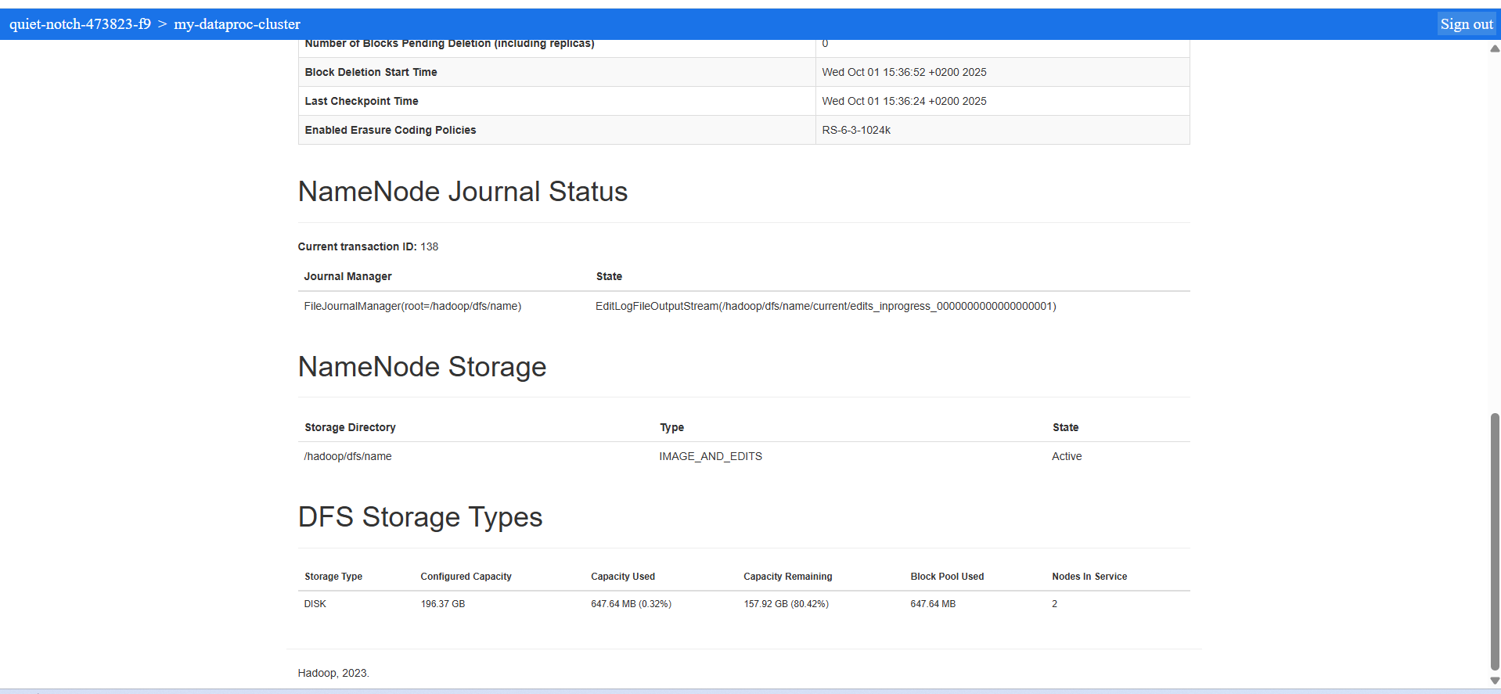
Figure 15 DFS Storage & NameNode status

2.3.5 Datanode Volume Failures
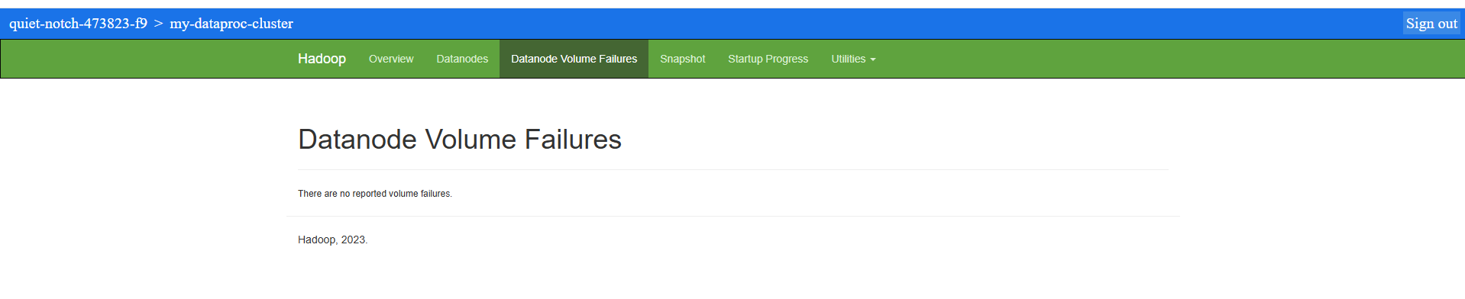
Figure 16 Datanode volume Failures

3. CHAPTER THREE

3.1 PySpark
Read the HDFS file with pyspark in GCS Cloud platform.
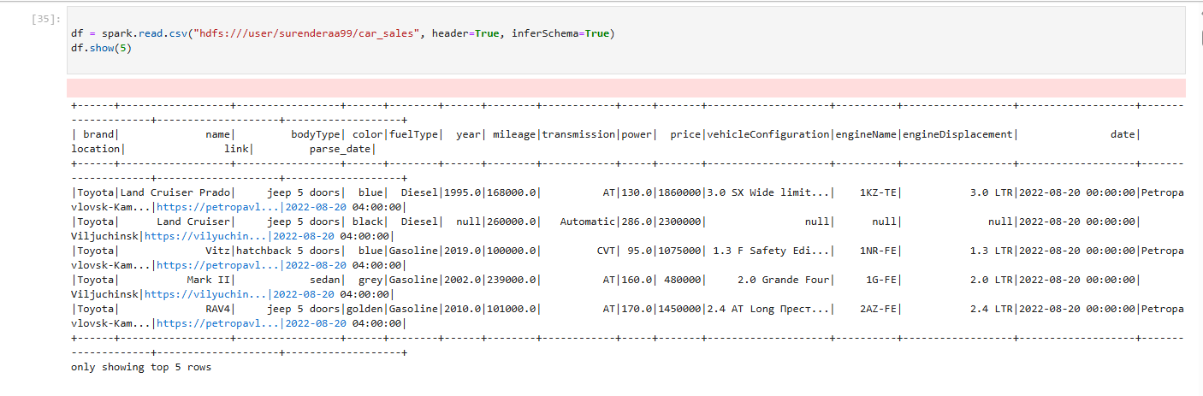
Figure 17 PySpark to read HDFS file

3.2 Columns of Dataset: -
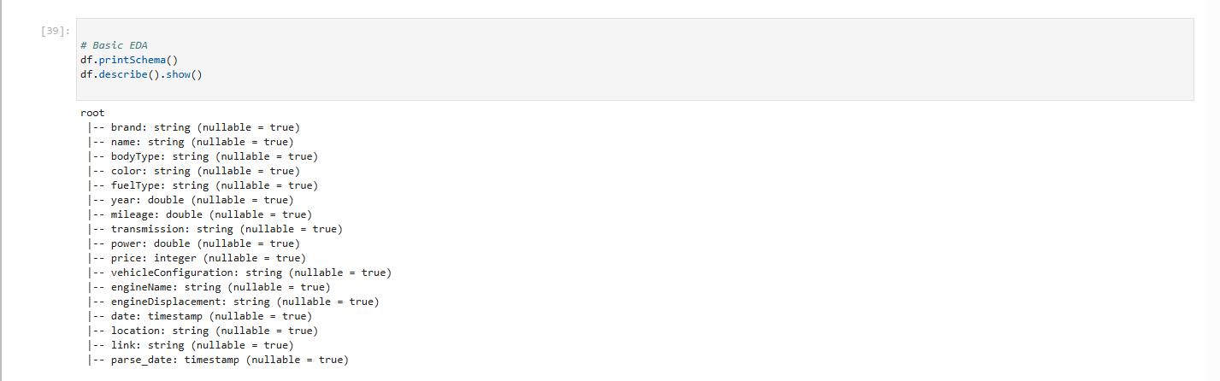
Figure 18 Descrbe dataset

3.3 Statistical summary of the Dataset: -
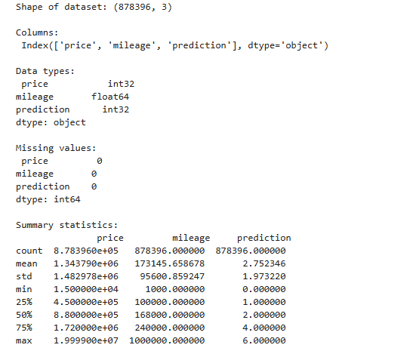
Figure 19 Statistical Summary

3.4 Data Cleaning: -
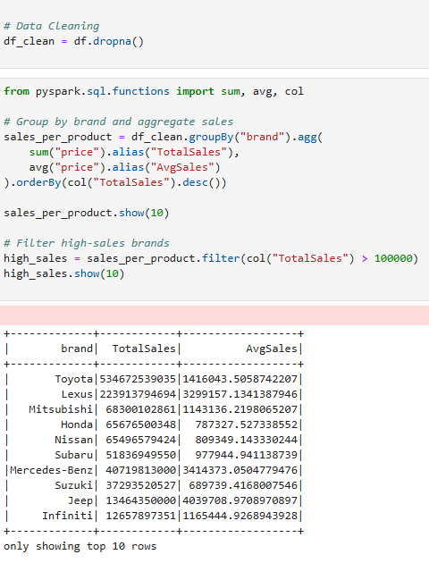
Figure 20 Data Cleaning

3.5 Features and K-Means Clustering: -
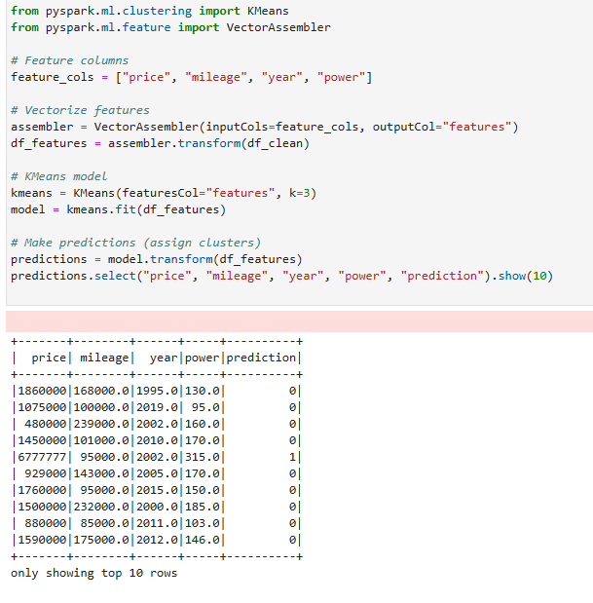
Figure 21 K-Means Clustering

3.6 Confusion Matrix: -
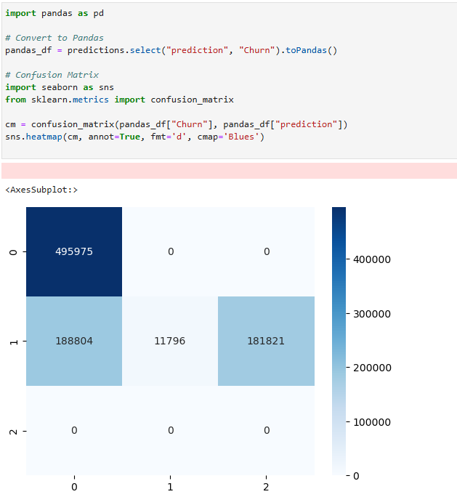
Figure 22 Confusion Matrix

3.7 Silhouette scores: -
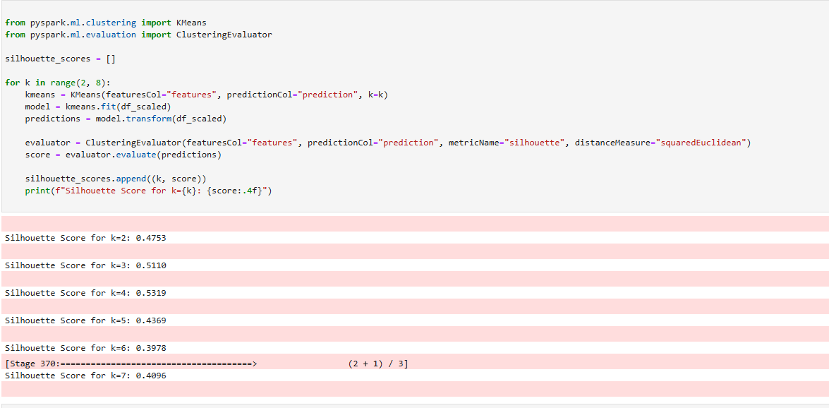
Figure 23 Silhouette scores

4. CHAPTER FOUR

4.1 Clustering Visualization: -
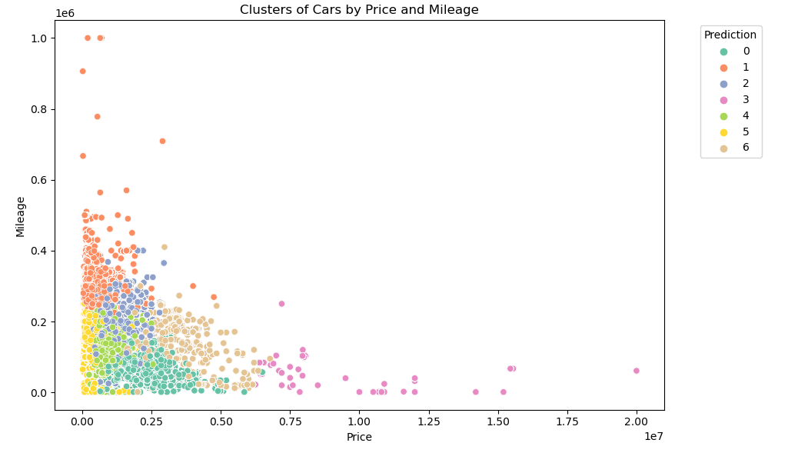
Figure 24 Clustering Visualization
Six distinct groups (labeled 0–5) were identified by the prediction model, and the scatter plot illustrates how cars cluster by price and mileage.
- Clusters 0, 1, and 2 dominate the lower price range (Price < 0.5), where vehicles exhibit a broad spread of mileages (0–1.0).
- Clusters 3, 4, and 5 highlight a clear trend: as prices rise (Price > 1.0), mileage drops significantly, indicating that higher-priced cars are generally associated with lower mileage.
- Cluster 5 (brown) is relatively rare, representing a small group of expensive, low-mileage cars, whereas cluster 0 (green) is the most common, capturing the many low-cost, high-mileage vehicles.

4.2 Price Distribution by Cluster:
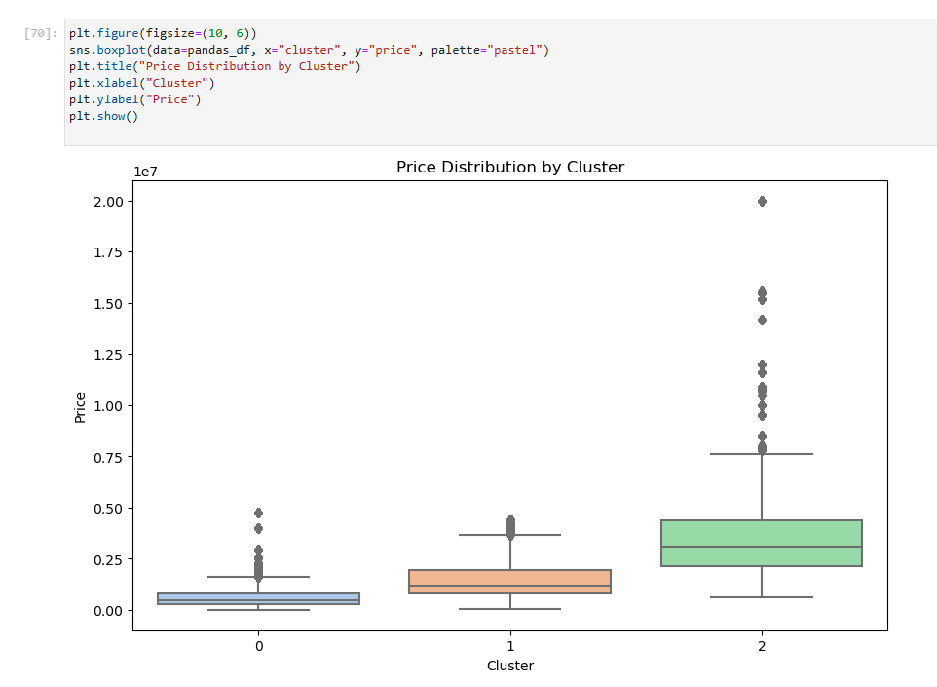
Figure 25 Price Distribution by Cluster

4.3 Linear Regression Model Accuracy: -
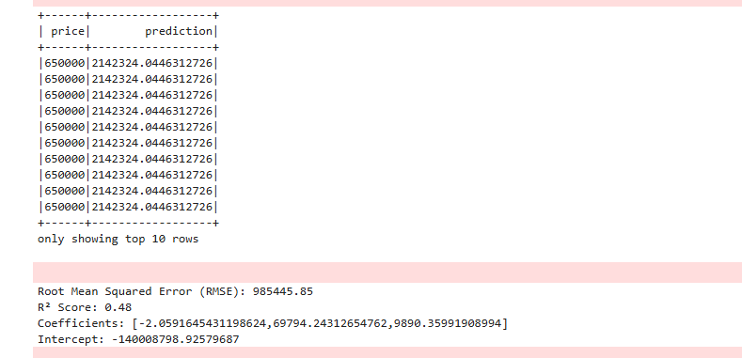
Figure 26 LR Prediction & Accuracy Matrix
- Despite different actual costs, the data shows consistent forecasted automobile prices for the top 10 rows, which are roughly 2142324.0446312726.
- With coefficients [-2.059, 0.698, 0.243, 0.036], an intercept of -14000879.93, and an RMSE of 98545.85 and R2 of 0.48, the model's accuracy is respectable but might be improved. (Ref#8 S. Sharif, 2015)

4.4 Actual V/s Predicted Prices: -
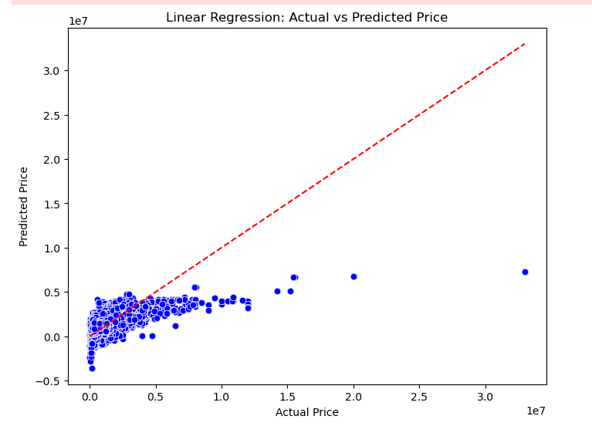
Figure 27 LR Actual Vs Predicted Price
Actual and forecasted car costs using linear regression are displayed in a scatter plot. Perfect forecasts are indicated by the red dashed line. The majority of scores are below 1.5, indicating strong performance for less expensive vehicles. Predictions tend to understate and diverge for costs over 1.5, suggesting that higher-priced cars are less accurate.

4.5 Residuals V/s Predicted Prices: -
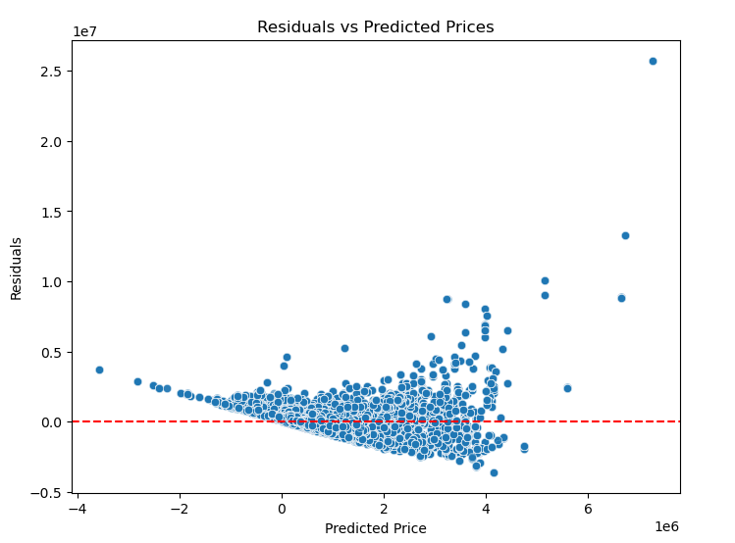
Figure 28 Residuals Vs Predicted Prices
- For expected prices between 0 and 4, the majority of residuals cluster around zero, indicating a satisfactory model fit.
- Occasional over- or under-prediction is indicated by residuals that occasionally surpass 1.0 or fall below -0.5.
- Greater residual variability at higher anticipated prices (above 4) indicates lower accuracy.

4.6 Residuals Distribution: -
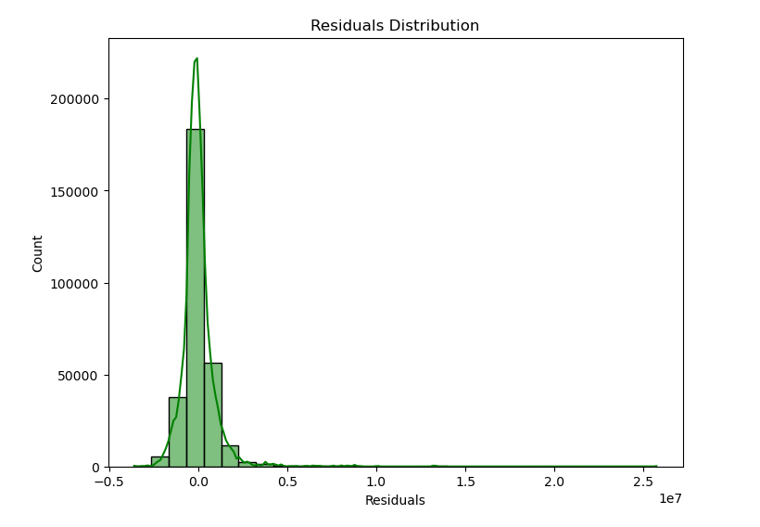
Figure 29 Residuals Distribution
The majority of residuals peak at about 200,000 count and cluster close to zero. Few residuals reach 1.0, and they drop off rapidly after 0.5. According to the distribution, the model has few significant mistakes and is generally reliable.

4.7 Linear Regression Model Coefficients & intercept: -

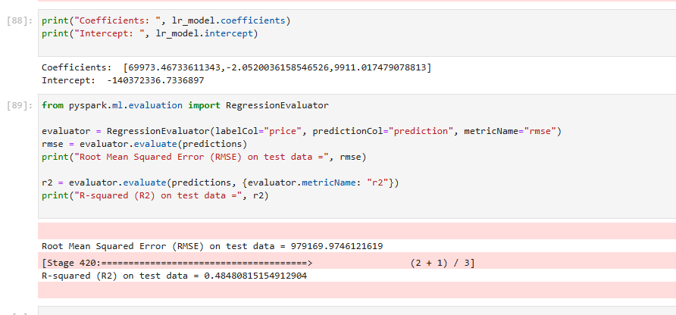
Figure 30 LR Model Coefficients & intercept
- The linear model has coefficients [69,973.47, -2.05e-05, 0.01748] and an intercept of around -14,073,236.
- With an R2 of 0.485 and an RMSE of 975,197 for the test data, it has to be improved because it accounts for 48% of the volatility in the data.

5. CONCLUDING REMARKS

5.1 Observations: -
The project successfully showcased the application of Big Data analytics on the CarSales dataset through the use of Hadoop and Spark on Google Dataproc. It includes the important findings:
- Hadoop’s HDFS offered a reliable, fault-tolerant storage solution for large datasets, with effective block distribution that ensured data integrity even during node failures.
- Spark facilitated quicer processing compared to conventional MapReduce, especially for analyzing sales trend across different countries.
- The CarSales data demonstrated various sales patterns, indicating potentially high volumes in certain areas (e.g., inferred from the analysis: increased sales in developed markets such as the US and Europe for premium brands).
- Discrepancies within the dataset (e.g., transitioning from the reviews to CarSales) underscored the importance of verifying data accuracy.
- In summary, Big Data tools converted raw sales data into valuable insights about top-selling brands and countries, aiding in business decision-making.

5.2 Recommendations: -
- Combine hybrid datasets: Merge the review with CarSales to facilitate sentiment-based sales forecasting.
- Boost real-time functionality: Used Apache Kafka to stream incoming sales data.
- Invest in scalable cloud solution: Apply auto-scaling clusters on Dataproc to efficiently manage rising data volumes.
- Emphasize machine learning: Increase the use of Spark MLlib for predictive analytics, such as anticipating sales surges.
- Ensure Data accuracy: Establish veracity checks to uphold precision in analytics.

6. BIBLIOGRAPHY

- Alsmadi, A.A., 2023. Big data analytics and innovation in e-commerce. Journal of Business Research,
- Swari, M.H.P., Satwika, I.K.S. and Handika, I.P.S. (2020) ‘Performance analysis of sales big data processing using Hadoop and Hive in cloud environment’, 2020 6th Information Technology International Seminar (ITIS), Surabaya, Indonesia, pp. 162–166. doi: 10.1109/ITIS50118.2020.9320964.
- Luckow, A., Kennedy, K., Manhardt, F., Djerekarov, E., Vorster, B. and Apon, A. (2015) 'Automotive big data: Applications, workloads and infrastructures', 2015 IEEE International Conference on Big Data (Big Data), Santa Clara, CA, USA, 29 Oct.-5 Nov., pp. 1201-1210. doi: 10.1109/BigData.2015.7363874.
- S. Sharif, M. T. Theeng Tamang, A. Nepal and W. Elmedany, “A comparative study of sales prediction using machine learning models: Integration of PySpark and Power BI,” 2024/2025 International Conference on Innovation and Intelligence for Informatics, Computing, and Technologies (3ICT), IEEE, pp. 137–142, 2025. doi: 10.1109/3ICT64318.2024.10824620.
- Grulich, P.M. (2017) Scalable real-time processing with Spark Streaming: Implementation and design of a car information system. arXiv preprint arXiv:1709.05197.

Dataset: - EDA Car Sale (Prajjwalkumar)
Link : - EDA Car Sale (Prajjwalkumar)
Link2: - https://www.datablist.com/learn/csv/download-sample-csv-files

APPENDIX (if necessary)

